**Jmeter-Logic Controllers**

**Simple Controller:**

Simple controller is used to group together

Add simple controller by Add>>Logical Controller>>Simple Controller

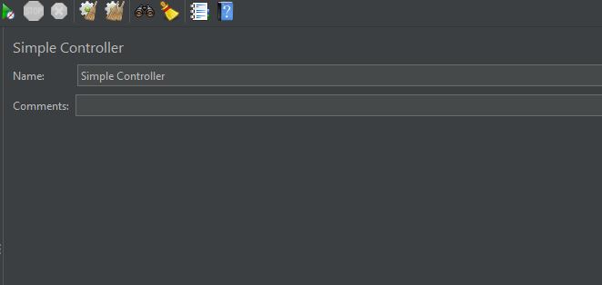

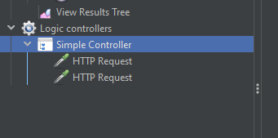

**Once Only Controller:**

Whatever is placed inside the only once controller will be executed only once

Add once only controller by Add>>Logical Controller>>Once Only Controller

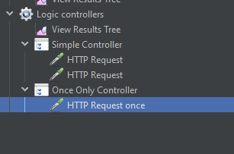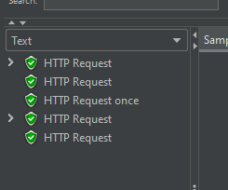

**Module Controller:**

Module Controller is used to add a test fragment to the threads. Which can be used to avoid the duplication of same steps

Add Module controller by Add>>Logical Controller>>Module Controller

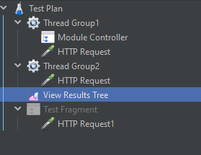 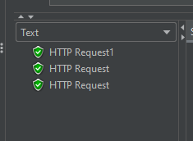

**Include Controller:**

It is used to add a test fragment to the required thread group

Add Include controller by Add>>Logical Controller>>Include Controller

